**Name –** Wajge Omkar Santosh

**Class –** BE Artificial Intelligence and Data Science.

**Roll No. –** 60

**Practical No. 04 -** Write a program for implementing security measures in an IIoT system.

**Implementing Seurity Measures for Industry by using IIOT. Circuit Diagram –**

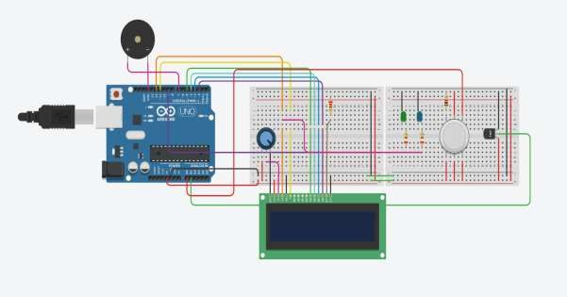

**Source Code –**

#include <LiquidCrystal.h>

// Initialize the LCD with the pin numbers LiquidCrystal lcd(12, 11, 5, 4, 3, 2);

int V_GasSen = 0; int V_TempSens = 0;

void setup() {

pinMode(A0, INPUT); // Gas sensor pin pinMode(A1, INPUT); // Temperature sensor pin pinMode(7, OUTPUT); // Buzzer pin

pinMode(9, OUTPUT); // LED for gas detection pinMode(12, OUTPUT); // LED for temperature warning

lcd.begin(16, 2); // Initialize the LCD with 16 columns and 2 rows

}

void loop() {

// Read gas sensor value V_GasSen = analogRead(A0);

// Read temperature sensor value and calculate temperature V_TempSens = -40 + 0.488155 * (analogRead(A1) - 20);

// Display temperature and gas status on the LCD lcd.clear(); // Clear the LCD

lcd.setCursor(0, 0); // Set cursor to the first row lcd.print("Temperature: "); // Print temperature label lcd.print(V_TempSens); // Print temperature value lcd.print(" C"); // Print temperature unit

lcd.setCursor(0, 1); // Set cursor to the second row lcd.print("Gas: "); // Print gas label lcd.print(V_GasSen); // Print gas sensor value

// Check for alerts

if (V_GasSen >= 250) {

tone(7, 523, 1000); // Play tone if gas is detected digitalWrite(9, HIGH); // Turn on the gas detection LED lcd.clear();

lcd.setCursor(0, 0);

lcd.print("ALERT: Gas Detected");

} else {

digitalWrite(9, LOW); // Turn off the gas detection LED

}

if (V_TempSens >= 70) {

tone(7, 523, 1000); // Play tone if temperature exceeds the threshold digitalWrite(12, HIGH); // Turn on the temperature warning LED lcd.clear();

lcd.setCursor(0, 0); lcd.print("ALERT: Temp High");

} else {

digitalWrite(12, LOW); // Turn off the temperature warning LED

}

delay(1000); // Delay for one second

}

**Output –**

